Terraform-03

Creating a file wild.txt with variables defined in variables.tf file.
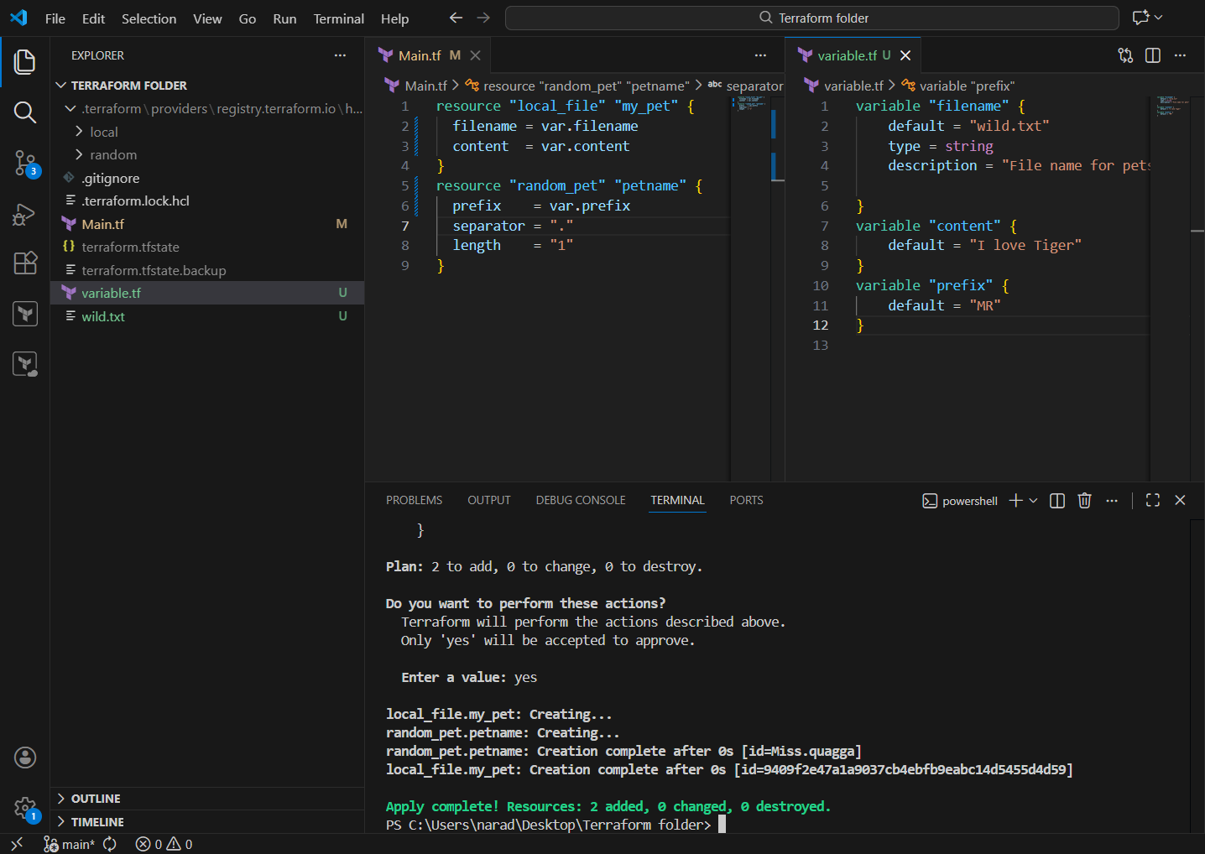

Command line flags:
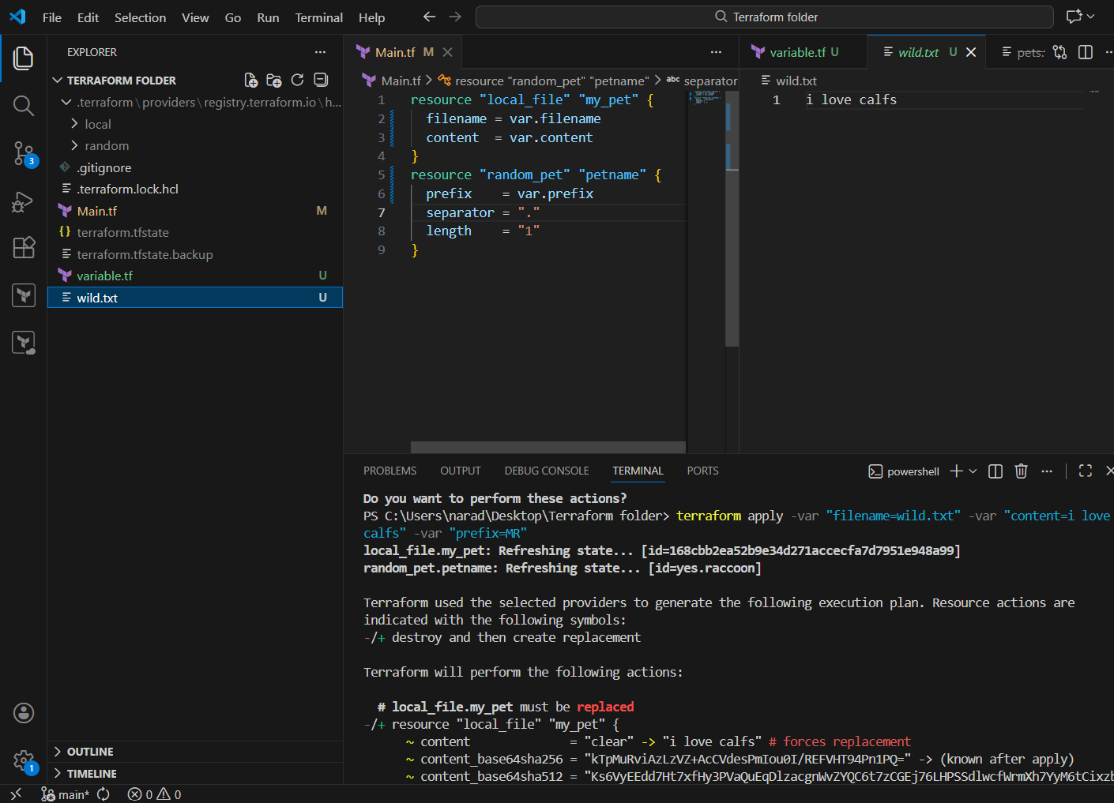

Environmental Variables:

These are Terraform environment variables.
Any environment variable that starts with TF_VAR_ is treated by Terraform as an input variable value.
Terraform automatically:
- Removes TF_VAR_
- Matches the remaining name with a variable in .tf files
- Uses the value during terraform plan / apply

Examples:
Env:TF_VAR_content = "I love calfs"
➡ This sets the Terraform variable content
Env:TF_VAR_filename = "wild.txt"
➡ This sets the Terraform variable filename
Env:TF_VAR_content = "I love Deer"
➡ This updates the same variable content (old value is replaced)
Env:TF_VAR_prefix = "Miss"
➡ This sets the Terraform variable prefix

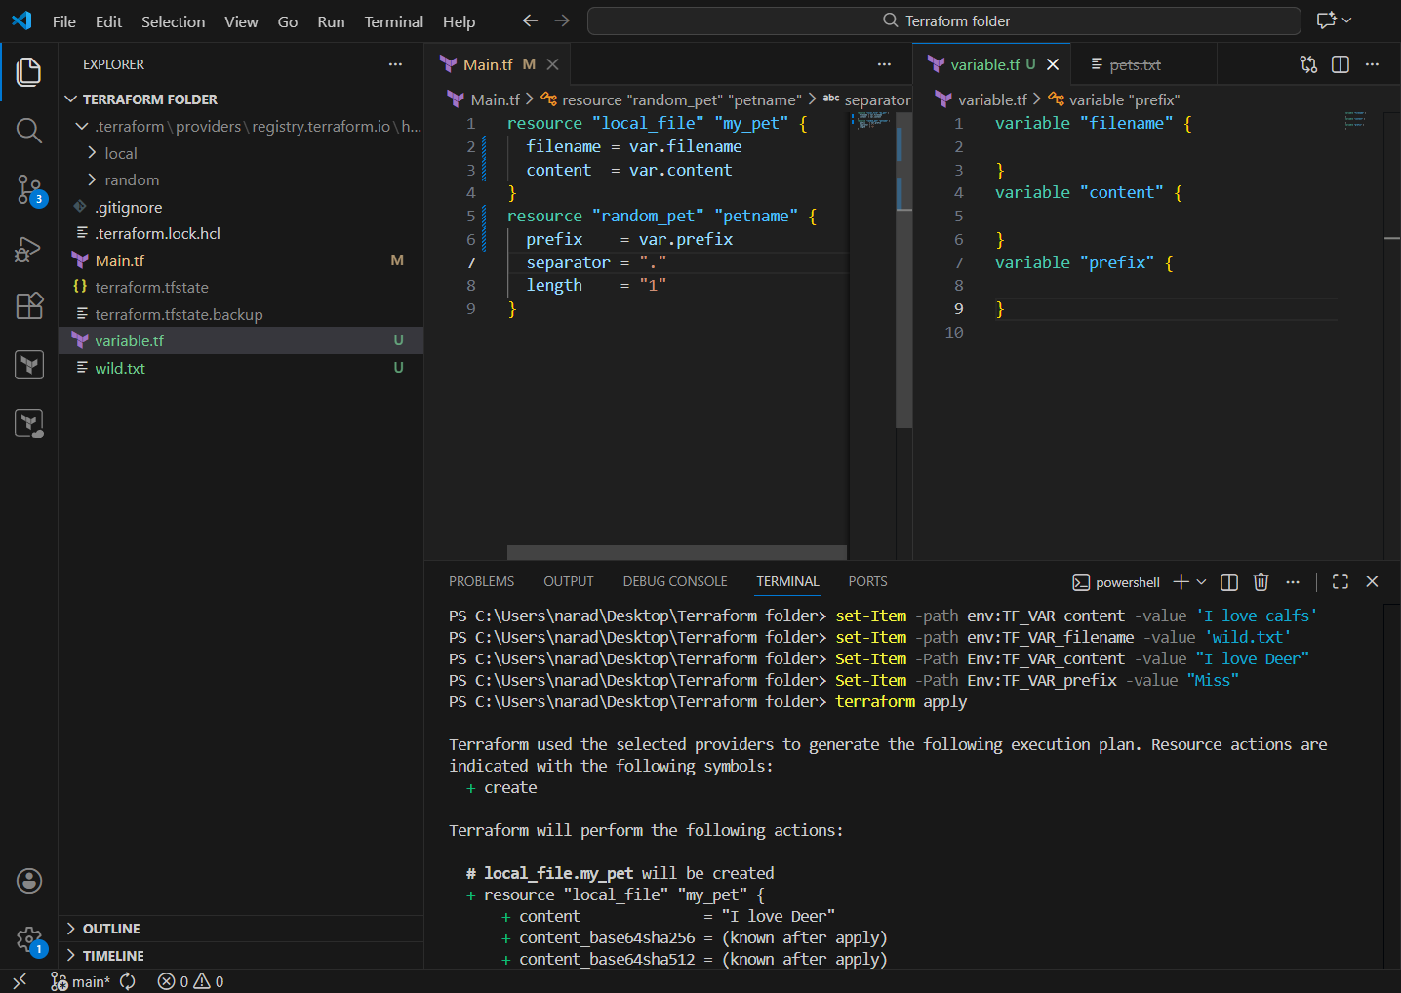
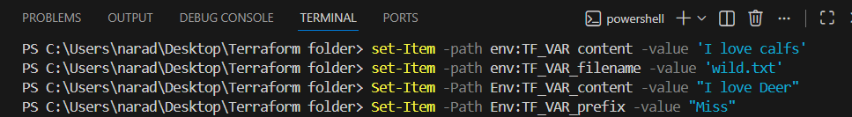
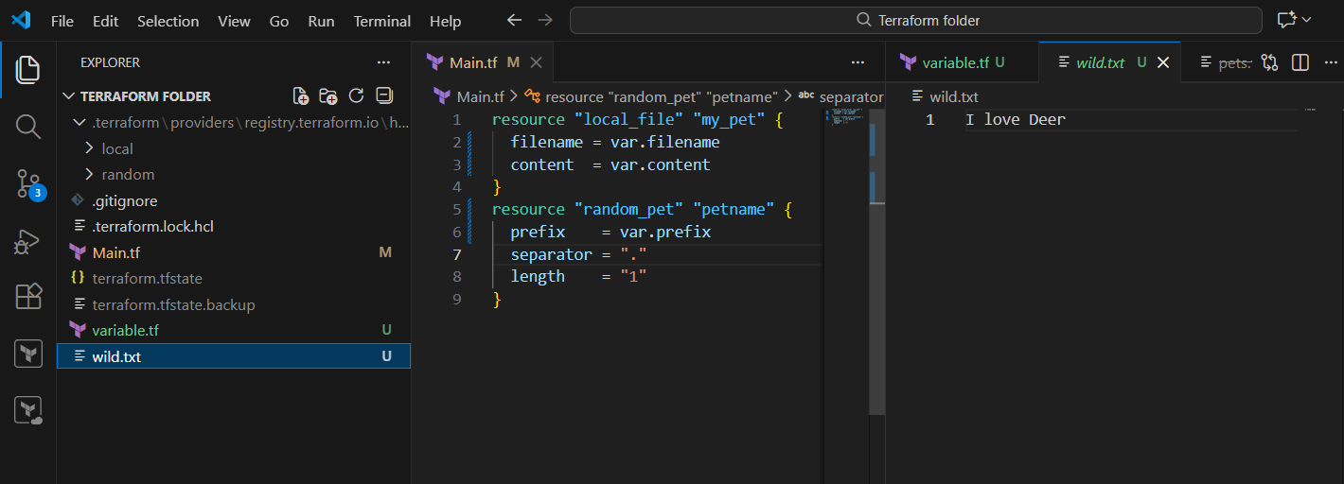

What is variable definition precedence
When the same Terraform variable is given in multiple places, Terraform follows a fixed priority order to decide which value to use.
Highest priority value wins, others are ignored.

Variable precedence order (Highest → Lowest)
- Command line -var
- Command line -var-file
- *.auto.tfvars files
- terraform.tfvars
- Environment variables (TF_VAR_)
- Default value in variable.tf

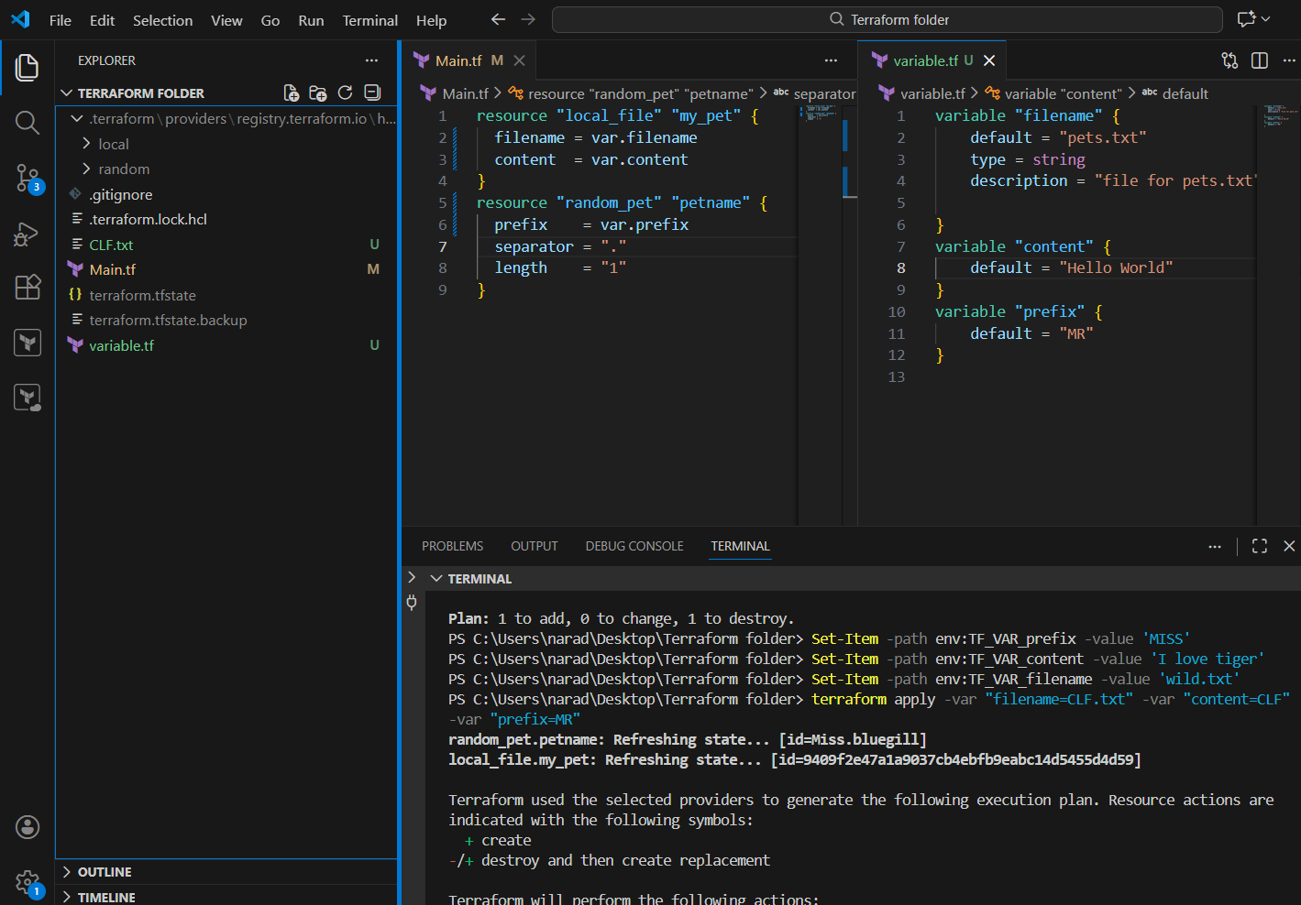
CLF.txt created first

Create one Jenkins job using Maven Project for the code below with two stages:
Stage 1: Git clone
Stage 2: Maven Compilation Code: https://github.com/betawins/java-Working-app.git

Prerequisites
- Jenkins installed and running
- Maven Integration Plugin installed in Jenkins
- Git Plugin installed in Jenkins
- Maven configured in:
  - Jenkins → Manage Jenkins → Global Tool Configuration
- GitHub repository is public

Step-by-Step Implementation

Install Maven Integration Plugin
- Jenkins Dashboard
- Manage Jenkins
- Plugins
- Go to Available plugins
- Search:
- Maven Integration
- ✅ Select Maven Integration Plugin
- Click Install

Step 1: Create a Jenkins Job
- Open Jenkins Dashboard
- Click New Item
- Enter job name:
- java-maven-build
- Select Maven Project
- Click OK

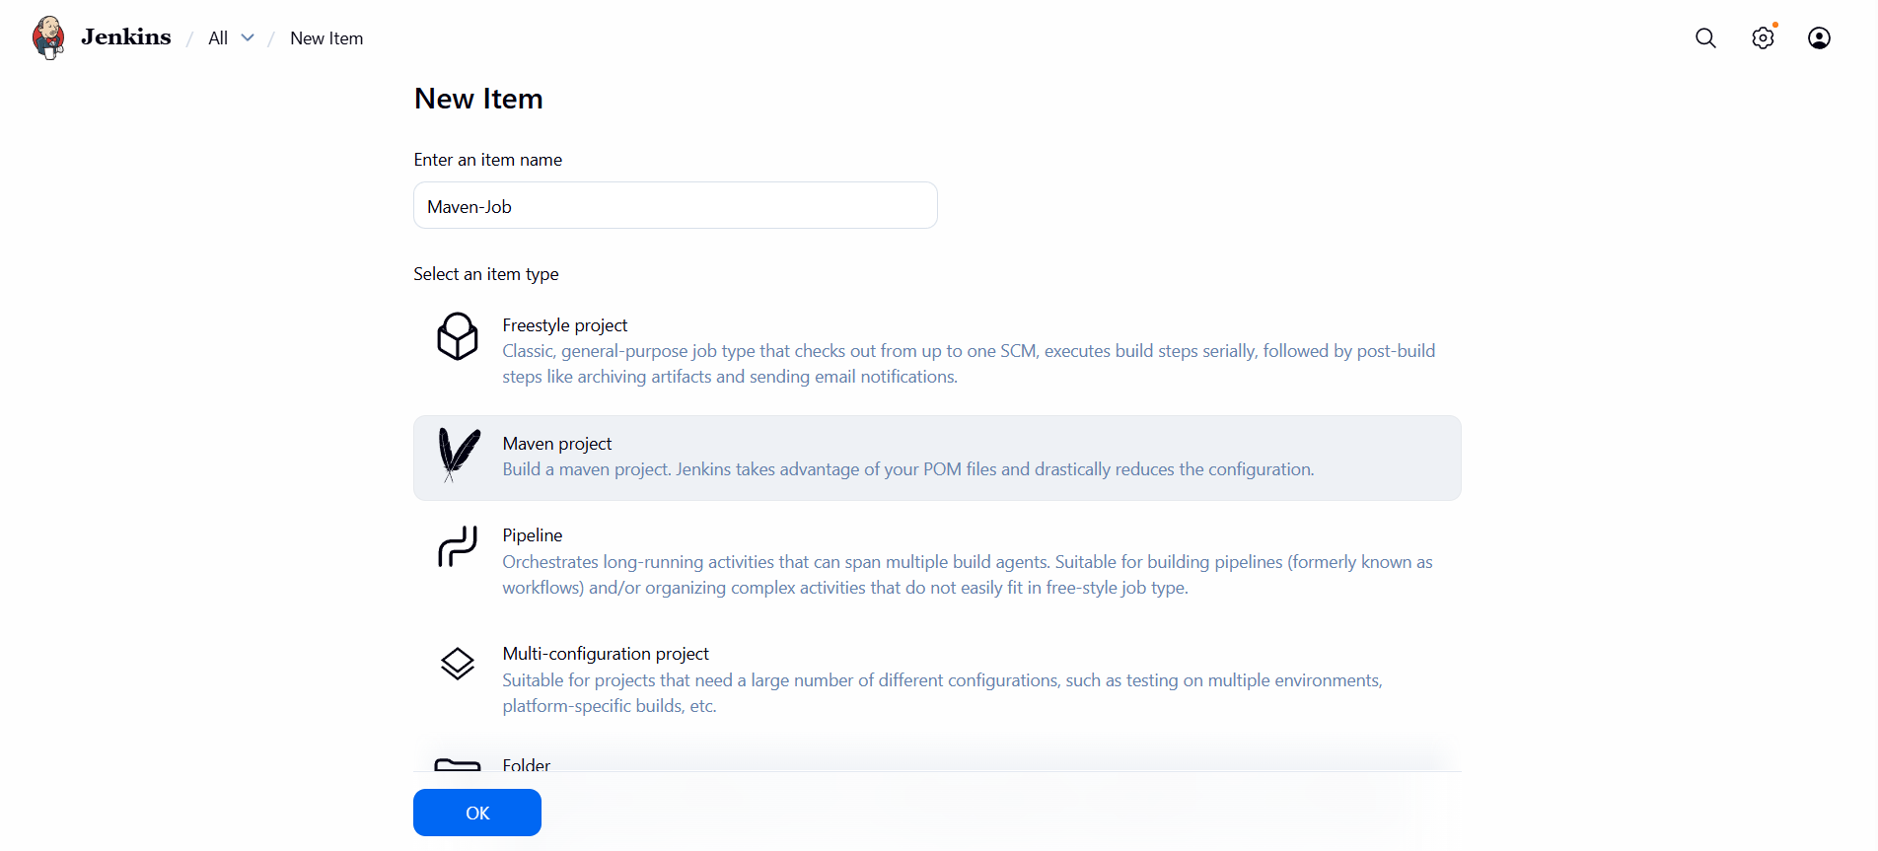

Step 2: Configure Stage 1 – Git Clone
- Click Configure
- Go to Source Code Management
- Select Git
- Enter:
  - Repository URL
  - https://github.com/betawins/java-Working-app.git
  - Branch Specifier
  - */main
  - Credentials: None (public repo)
✔ This completes Stage 1: Git Clone

Step 3: Configure Stage 2 – Maven Compilation
- Scroll to Build section
- Enter:
  - Root POM
  - pom.xml
  - Goals and options
  - clean compile
✔ This completes Stage 2: Maven Compilation

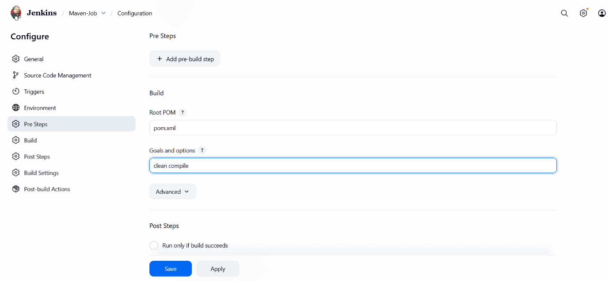

Now click on build a job

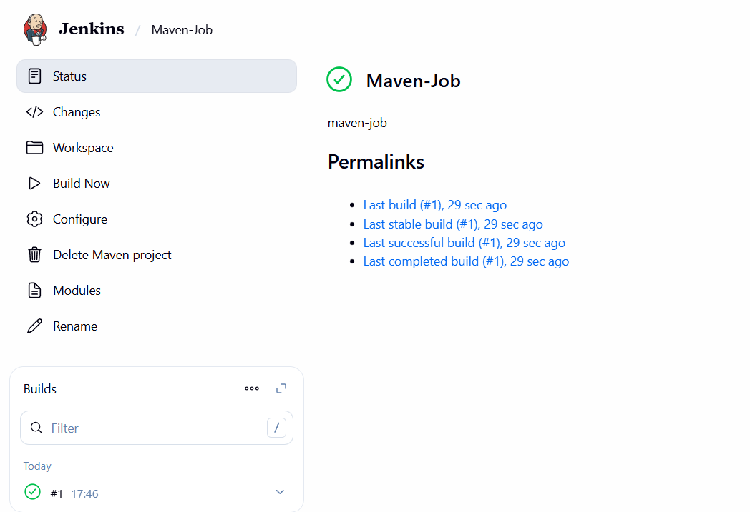

Use the same code and create a parameterized job in Jenkins with:
Stage 1: Git clone
Stage 2: Maven Compilation Code: https://github.com/betawins/java-Working-app.git

Prerequisites
- Jenkins installed and running
- Git installed on the Jenkins server
- JDK installed and configured in Jenkins
- Maven installed and configured in Jenkins
- Git Plugin and Maven Integration Plugin installed

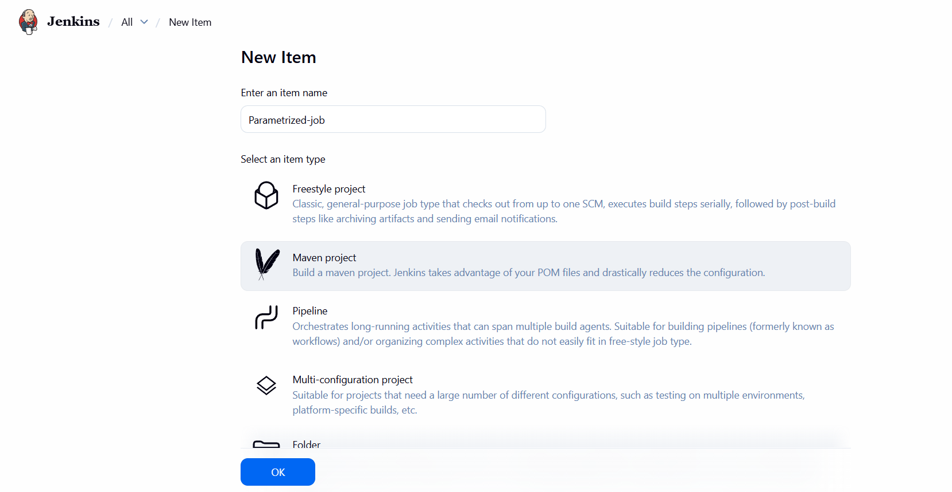

Select this project is parametrized and click on add parameters and add these two parameters

PARAMETER 1
Name : BRANCH
Default Value : main
Description : Git branch name

PARAMETER 2
Click Add Parameter → String Parameter
Name : MAVEN_GOAL
Default Value : compile
Description : Maven goal to run

BUILD (AFTER pom.xml)
Root POM : pom.xml
Goals and options : ${MAVEN_GOAL}

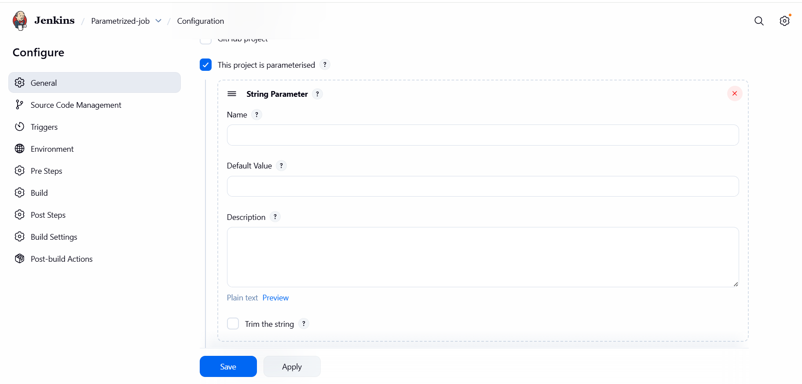

Click on build a job with parameters
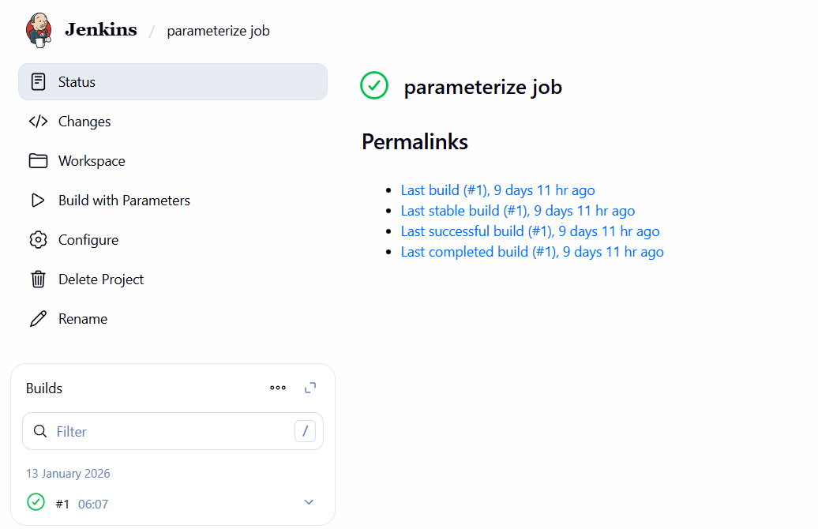

Global Variables in Jenkins
Global variables in Jenkins are predefined environment variables that are automatically available during a build and can be used across jobs, pipelines, and build steps.

Common Jenkins Global Variables
BUILD_NUMBER – Current build number
BUILD_ID – Build ID (usually same as build number)
JOB_NAME – Name of the Jenkins job
BUILD_URL – URL of the current build
WORKSPACE – Directory where Jenkins stores the job files
NODE_NAME – Name of the Jenkins node running the job
EXECUTOR_NUMBER – Executor running the build
JENKINS_HOME – Jenkins home directory
GIT_BRANCH – Git branch being built (when Git plugin is used)
GIT_COMMIT – Git commit ID of the build

1. BUILD_NUMBER
What it is: Current build number
Use: Versioning, tagging artifacts
Example use:
echo "Build number is $BUILD_NUMBER"

2. JOB_NAME
What it is: Name of the Jenkins job
Use: Logging, notifications
Example use:
echo "Job running: $JOB_NAME"

3. WORKSPACE
What it is: Directory where code is checked out
Use: Referencing files, scripts, artifacts
Example use:
cd $WORKSPACE
ls

4. BUILD_URL
What it is: URL of the current build
Use: Email / Slack notifications
Example use:
echo "Build URL: $BUILD_URL"

5. NODE_NAME
What it is: Jenkins node running the job
Use: Debugging multi-node builds
Example use:
echo "Running on node: $NODE_NAME"

6. EXECUTOR_NUMBER
What it is: Executor ID on the node
Use: Parallel job troubleshooting
Example use:
echo "Executor: $EXECUTOR_NUMBER"

7. JENKINS_HOME
What it is: Jenkins installation directory
Use: Backup, plugin inspection
Example use:
echo "Jenkins home: $JENKINS_HOME"

8. GIT_BRANCH
What it is: Git branch being built
Use: Environment-specific builds
Example use:
echo "Branch: $GIT_BRANCH"

9. GIT_COMMIT
What it is: Git commit ID
Use: Traceability, rollback
Example use:
echo "Commit ID: $GIT_COMMIT"

10. BUILD_TAG
What it is: Unique tag for the build
Use: Docker image tagging
Example use:
docker build -t app:$BUILD_TAG .

